Assessment Schedule – 2014
Biology: Demonstrate understanding of genetic variation and change (91157)
Evidence Statement

Q | Evidence |  |  |  |  | Achievement |  | Merit |  |  | Excellence
ONE  (a)  (b)  (c)  (d) | Genotype: WwDd.  Punnett square: Accurately completed to show WwDd x WwDd cross. Gametes are WD, Wd, wD, wd.  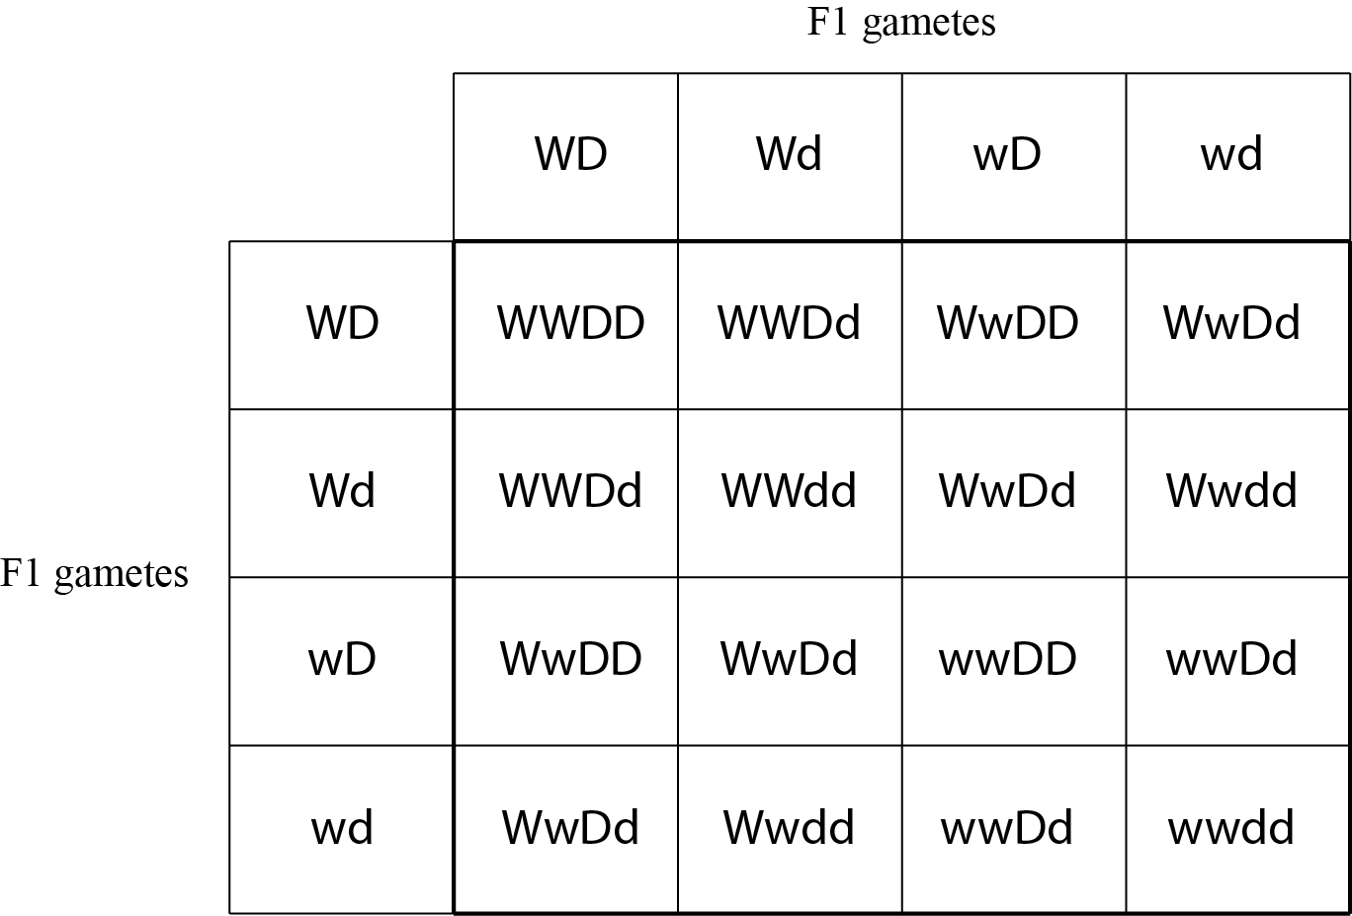  Phenotype ratio & appearance:  9 white disk:3 yellow disk:3 white round:1 yellow round  Linked genes occur on the same chromosome / accept diagram  Crossing over occurs (during meiosis) and is the exchange of alleles / segments of chromosomes / DNA between homologous / pairs chromosomes / accept annotated diagram (does not have to show resulting gametes).  Crossing over can separate linked genes.  Linked genes occur on the same chromosome and are inherited together  Crossing over exchanges alleles between homologous / pairs of chromosomes therefore new combinations of alleles result.  Crossing over exchanges alleles between homologous / pair chromosomes, therefore genes that are linked (on the same chromosome) can be separated (if it occurs between them).  Linked genes reduce genetic variation in a population because they are on the same chromosome and more likely to stay together and end up in the same gamete / pass on same parental allele combination / offspring will display phenotypes similar to that of the parents  However, crossing over exchanges genetic material between homologous chromosomes and results in new combinations of alleles. New allele combinations end up in gametes / are different from parental allele combinations therefore increase genetic variation. |  |  |  |  | - Genotype identified correctly.  - Punnett square completed with correct gametes and F2  - Phenotype ratio correct.  - Appearance correct.  - Describes linked genes OR diagram.  - Describes crossing over OR diagram.  - Describes how crossing over affects linked genes.  - Describes crossing over increases variation AND linked genes reduces variation. |  | - Explains linked genes.  - Explains how crossing over affects genetic variation.  - Explains how crossing over affects linked genes OR well-annotated diagram. |  |  | - Discusses that linked genes reduce genetic variation in a population.  - Discusses the effect crossing over has on genetic variation in a population.
NØ |  | N1 | N2 | A3 | A4 |  | M5 |  | M6 | E7 |  | E8
No response; no relevant evidence. |  | Describes any ONE statement from Achievement. | Describes any TWO statements from Achievement. | Describes any THREE statements from Achievement. | Describes any FOUR statements from Achievement. |  | Explains any TWO statements from Merit. |  | Explains any THREE statements from Merit. | Discusses ONE criterion for Excellence. |  | Discusses BOTH criteria for Excellence.

Q | Evidence | Achievement | Merit | Excellence
TWO  (a)  (b)  (c) | (Permanent) change in DNA / gene (base sequence).  Gametic mutations occur only in sex cells / egg / sperm / pollen (not gametes)  Gametic mutations are passed onto the next generation (via reproduction / fertilisation)  Gene pool is all the alleles in a population.  Natural selection –Some phenotypes / traits / individuals are better suited to the environmental conditions. These individuals survive and reproduce.  Better suited alleles increase in frequency OR less suited alleles decrease in frequency.  Those individuals with phenotype better suited to the environment have an increased chance of survival and reproduction / produce (more) offspring / implies new generations OR those individuals with phenotype less suited to the environment have a decreased chance of survival and reproduction / less offspring.  An allele that is not favourable will be selected against, due to the individual’s chances of survival and reproduction being reduced so allele frequency decreases OR An allele that is favourable will be selected for due to the individual’s chances of survival and reproduction increasing so allele frequency increases  A disadvantageous allele is unlikely to become established in the population (implies generations) as it is selected against due to its lower chance of survival and reproduction.  In this example the pear-shaped pumpkin / new allele is disadvantageous due to the seeds not being in the centre, therefore lower chance of seed dispersal and therefore do not grow / germinate and go on to reproduce, and the new allele is unlikely to be established. | - Defines mutation.  - Describes where gametic mutation occurs.  - Describes gene pool.  - Describes natural selection.  - Describes how natural selection can affect allele frequencies in gene pools. | - Explains how gametic mutations may be inherited.  - Explains natural selection.  - Explains how natural selection can affect allele frequencies in gene pools. | - Discusses why the pear-shaped pumpkin allele has not become established in the gene pool via natural selection.  - Discussion justified with appropriate reasons from the example Eg, pear–shaped pumpkin seeds less likely to disperse and therefore do not grow / germinate and go on to reproduce.

NØ |  | N1 | N2 | A3 |  | A4 | M5 |  | M6 | E7 |  | E8
No response; no relevant evidence. |  | Describes any ONE statement from Achievement. | Describes any TWO statements from Achievement. | Describes any THREE statements from Achievement. |  | Describes any FOUR statements from Achievement. | Explains any TWO statements from Merit. |  | Explains any THREE statements from Merit. | Discusses FIRST criterion for Excellence. |  | Discusses BOTH criteria for Excellence.
Q | Evidence |  |  |  | Achievement |  |  | Merit |  |  | Excellence
THREE | Genetic drift: Chance / random change in allele frequency of a population.  Migration: Individuals moving into OR out of a population  Allele frequency: the % of each allele in a gene pool.  Change of allele frequency –  Genetic drift:  Frequency of the alleles can change through (random) chance, especially if the population is or becomes small.  Migration:  Migration may change the frequency of alleles by adding alleles (immigration) increasing frequency or by removing alleles (emigration) decreasing frequency / losing allele.  If new / additional alleles are inheritable (implies successful reproduction), the frequency of these will increase  Effects on small population –  Genetic drift:  In a small population, accidental / natural mortality can have a larger proportional effect / more likely to lead to alleles becoming fixed / lost / reduced variation in population.  In a large population, accidental / natural mortality is less likely to lead to alleles becoming fixed / lost due to the buffer effect of the larger number of individuals therefore tend to have more genetic variation.  Migration:  Migration may change allele frequencies, especially in small populations when allele frequency present in immigrant or emigrant individual is not representative of those of the overall gene pool.  In a small population migration will have a larger effect. Individual leaving may carry the only copy of a particular allele leading to loss of allele from that population whereas in a larger population it is less likely an individual leaving will carry the only copy of an allele due to the larger numbers. |  |  |  | - Describes genetic drift.  - Describes migration.  - Recognises migration as a potential source of new alleles OR loss of rare alleles.  - Describes allele frequency. |  |  | - Explains genetic drift.  - Explains that migration may change allele frequency.  - Explains that the migrant has to reproduce within the population for the allele(s) to enter gene pool.  - Explains the effect of genetic drift on small populations.  - Explains the effect of migration on small populations. |  |  | - Discusses effect of genetic drift in a small population and large population.  - Discusses the migration effect on small and large populations.

NØ | N1 | N2 | A3 | A4 | M5 | M6 | E7 | E8
No response; no relevant evidence. | Describes any ONE statement from Achievement. | Describes any TWO statements from Achievement. | Describes any THREE statements from Achievement. | Describes any FOUR statements from Achievement. | Explains any TWO statements from Merit. | Explains any THREE statements from Merit. | Discusses ONE criterion for Excellence. | Discusses BOTH criteria for Excellence.

Cut Scores
 | Not Achieved | Achievement | Achievement with Merit | Achievement with Excellence
Score range | 0 – 6 | 7 – 12 | 13 – 19 | 20 – 24

